**Project Reflection Report**

**Sri Cafe**

**1.Project Title:** Sri Cafe – Responsive Online Cafe Website

**2.Intern Name:** Akula Sripriya

**3.College:** YJRDMS College of Engineering, JNTUK

**4.Duration:** two days

**5.Objective:** To design and develop a responsive and user-friendly website for a cafe, allowing customers to view menu items, place orders, and contact the cafe easily.

**6.Technologies Used:** Bootstrap, HTML, CSS, JavaScript.

**7.Project Description:**

* + The “Sri Cafe” website is a responsive and visually appealing web application designed to simulate a real cafe experience online.
  + The website includes three main sections: Home, About, and Contact.
  + The Home page showcases all cafe items neatly arranged with an option to place an order.
  + The About page highlights the cafe’s story and specialties.
  + The Contact page displays essential cafe details such as location, timings, and contact information.
  + The order and feedback forms are designed to send user details directly to the provided email address.

🡪Homepage: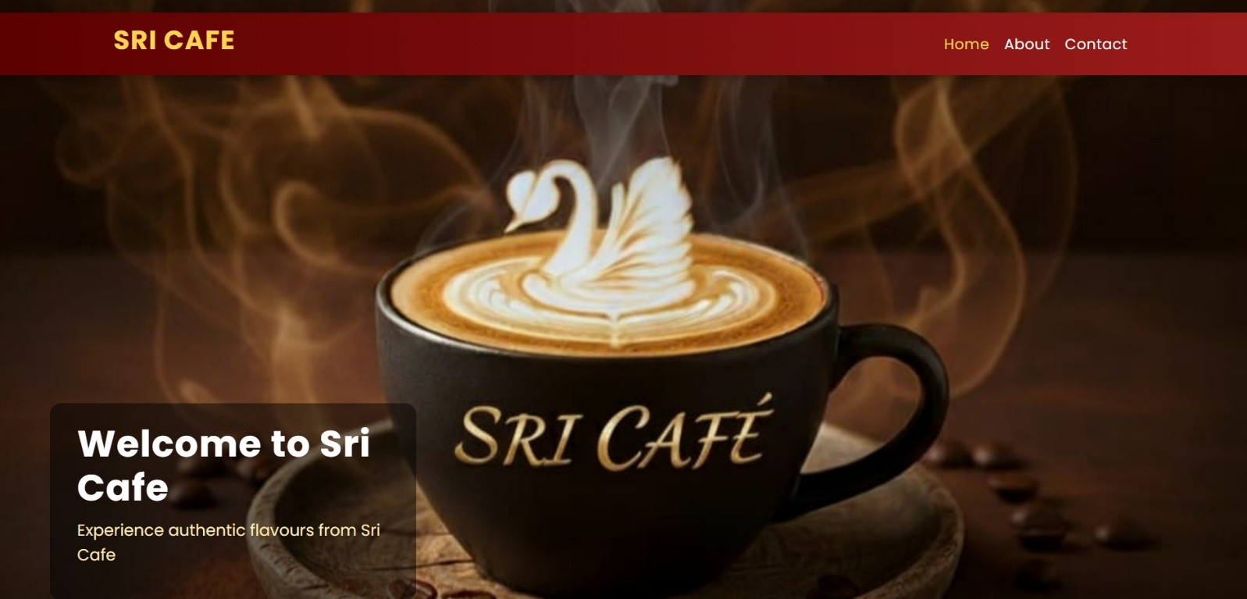



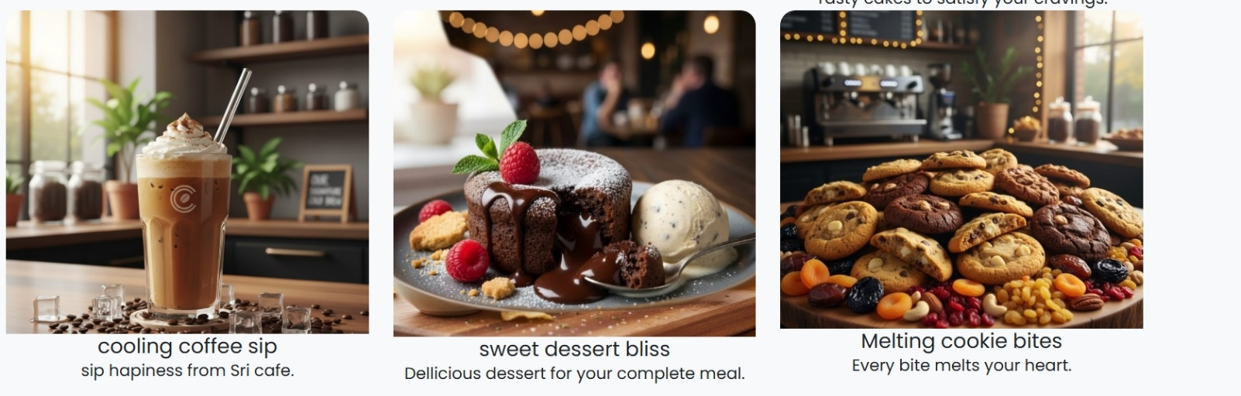

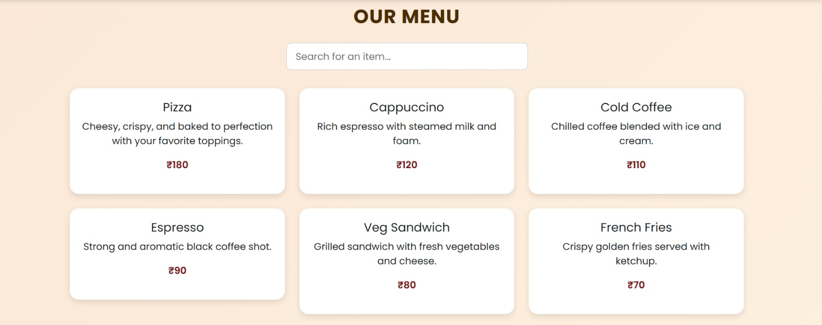

🡪About:

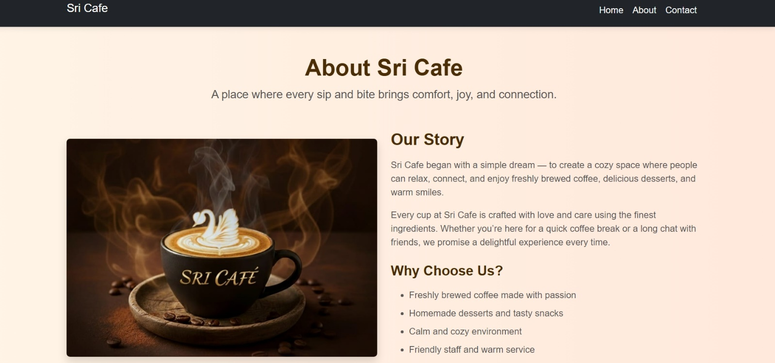

🡪Contact:

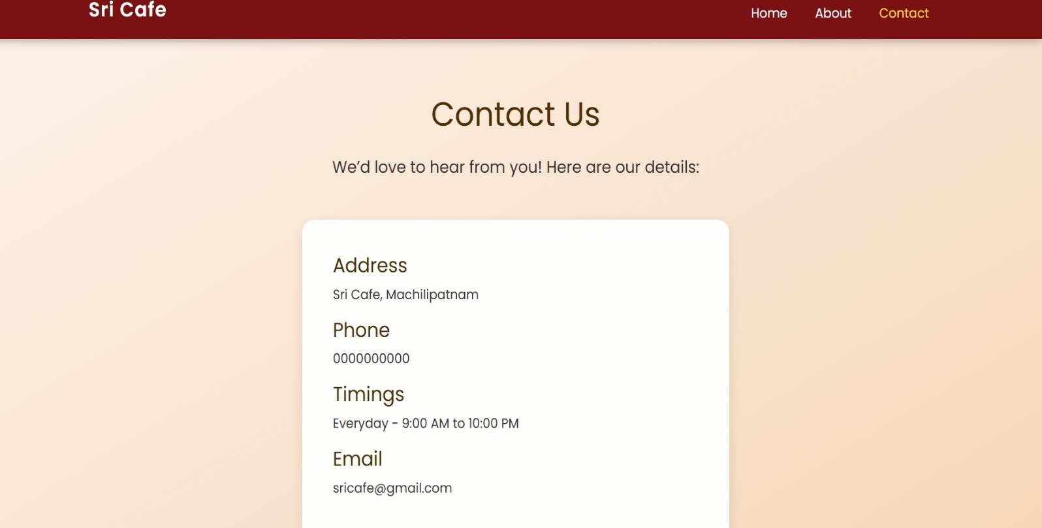

🡪Order process:

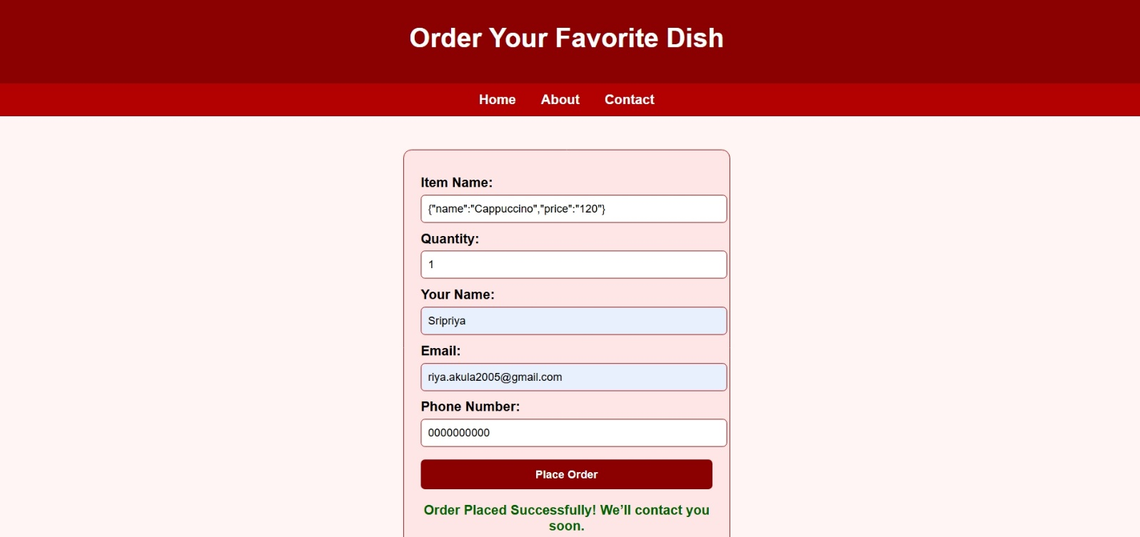

**8.Role and Responsibilities:**

* + Worked as a beginner handling the complete design, layout, and functionality of the website.
  + Designed responsive navigation bars and integrated order-placing and contact forms.
  + Implemented inter-page linking and enhanced user interaction using JavaScript.

**9.Challenges Faced:**

* + Implementing smooth redirection between pages without disturbing layout consistency.
  + Ensuring form data submission and debugging email sending issues.
  + Making the interface responsive and attractive across different devices.

**10.Learning Outcomes:**

* Improved knowledge of HTML, CSS, and Bootstrap for responsive design.
* Gained practical experience in integrating form handling through web methods.
* Strengthened problem-solving and debugging skills while developing a live-style project.

**11.Future Enhancements:**

* Connect the order system to a real database for dynamic item management.
* Add an admin dashboard for order tracking and user feedback analysis.
* Enhance security for form submissions and user data handling.

**12.Conclusion:**  
The Sri Cafe project helped me understand complete website development — from designing user interfaces to handling user input.  
This project gave me confidence to build full, responsive websites independently and improved my creativity and technical problem-solving skills.